May 5, 2011



Product Alert

Type of Notification: Product Safety Notification

FM Approvals has been notified by Emerson Process Management of a potential safety concern involving a limited number of FM Approved Rosemount 8711 Magnetic Flowmeters shipped between August 17, 2005 and December 9, 2010.

Company Identity: | Emerson Process Management
Name: | Emerson Process Management, Rosemount Flow Division
Address: | 12001 Technology Drive
 | Eden Prairie, MN| 55344

Contact Information: | Product information is available at:  www.emersonprocess.com/rosemount.  Customer Service Phone Numbers:  Rosemount USA 1-800-522-6277  or +1-303-527-5200 for outside North America  Rosemount Flow Europe +31 (0) 318 495 444  Rosemount Flow Asia +65 6777-8211  Rosemount Flow MEA +971 4 8118100  Technical Support can also be attained via e-mail by contacting  flow.support@emerson.com.

Product Identity: | Rosemount 8711 Magnetic Flowmeter Sensor
Description: | Rosemount identified a manufacturing nonconformance potentially affecting 8711 products manufactured between August 17th, 2005 and December 9, 2010 for a Class 1 Division 1 hazardous areas only (as identified by option code E5 in the model number). Rosemount determined through internal testing the encapsulation method used in the 8711 sensor manufacturing process during this time period did not consistently meet the protection requirements for a Class 1 Division 1 hazardous area.
Make/Model: | Rosemount 8711 Magnetic Flowmeter Sensor
Nameplate Data | Rosemount 8711 Magnetic Flowmeter Sensor with E5 Option on Label
FM Approval Status: | FM Approved

Hazard Involved:

Rosemount has issued a safety notification regarding FM Approved 8711 sensors with the E5 approval option when installed in a Class I, Division 1 area. The letter below was sent to all customers who have units covered under this safety notification.

Please read the letter below for a complete description of the potential hazard.

Thomas G. McCarty
FM Approvals, Quality Department
Norwood, MA, USA
+1 (1)781 255 4802
Email: Thomas.mccarty@fmapprovals.com

.

SAMPLE
Date: July 29, 2026

Plant/Product Safety Officer

Name:
Address:
Address:
State, Country:

IMPORTANT PRODUCT SAFETY NOTIFICATION

THIS LETTER NOTIFIES AFFECTED CUSTOMERS OF A POTENTIAL SAFETY CONCERN INVOLVING A LIMITED NUMBER OF ROSEMOUNT 8711 MAGNETIC FLOWMETERS SHIPPED BETWEEN AUGUST 17th 2005 AND DECEMBER 9, 2010.

OUR RECORDS INDICATE YOU RECEIVED THE AFFECTED PRODUCTS IDENTIFIED IN APPENDIX “A”. PLEASE FORWARD THIS INFORMATION TO ALL APPROPRIATE INDIVIDUALS WITHIN YOUR ORGANIZATION IMMEDIATELY.

PLEASE READ CAREFULLY

Rosemount identified a manufacturing nonconformance potentially affecting 8711 products manufactured between August 17th, 2005 and December 9, 2010 for Factory Mutual Class 1 Division 1 hazardous areas only (as identified by option code E5 in the model number). Rosemount determined through internal testing the encapsulation method used in the 8711 sensor manufacturing process during this time period did not consistently meet the protection requirements for a Factory Mutual Class 1 Division 1 hazardous area.

In applications where a flammable gas is able to migrate into the coil compartment of an improperly encapsulated 8711 sensor while multiple fault conditions are simultaneously occurring , ignition resulting in property damage, serious personal injury and/or death is possible. No related product failures have been reported to Rosemount and the likelihood of an incident related to this potential nonconformance is believed to be very low. Nonetheless, Rosemount has modified the 8711 sensor manufacturing process to ensure that all units with the E5 option code manufactured after December 2010 fully comply with all Factory Mutual Class 1 Division 1 hazardous area requirements.

Because each customer’s application is unique, customers must determine the precise impact on each of their applications and act accordingly. Customers may choose to continue to use potentially affected devices “as is” or replace them, depending upon the specific nature of their applications.

OPTIONS AVAILABLE TO YOU:

- USE “AS IS”
Should you determine the potentially affected 8711 magnetic flowmeter sensor is not installed in a Factory Mutual Class 1 Division 1 area no action on your part is required. If you choose this option, you must ensure the potentially affected unit will not be used in a Factory Mutual Class 1 Division 1 area in the future.

- RETURN AFFECTED UNITS TO ROSEMOUNT FOR REPLACEMENT
Should you determine a potentially affected 8711 magnetic flowmeter sensor is installed in a Factory Mutual Class 1 Division 1 area where flammable gas is continuously present under normal operating conditions, remove and replace the potentially affected units with new units manufactured after December 2010. Follow the instructions found in appendix A to return the existing units and obtain replacements.

IT IS VERY IMPORTANT THAT YOU:
- Immediately locate all affected Rosemount 8711 magnetic flowmeter sensors with the E5 option code identified in Appendix A.
- Review the options indicated above and take appropriate corrective action as needed.

If you resold or otherwise transferred any of the potentially affected products, please forward this important Product Safety Notification to the transferee immediately or provide Rosemount the name and address of the transferee so Rosemount can send them this important Product Safety Notice.

If anyone in your organization (or any transferee) has any questions regarding the situation, please contact our Flow Customer Solutions Center per the instructions in the attached appendix.

We apologize for any inconvenience this may cause you or your organization. Rosemount is committed to supplying our customers the best measurement products in the industry. Thank you for allowing Rosemount to serve you now and in the future.

Sincerely,

SAMPLE
Scott Anderson
President
Rosemount Flow Division
Emerson Process Management
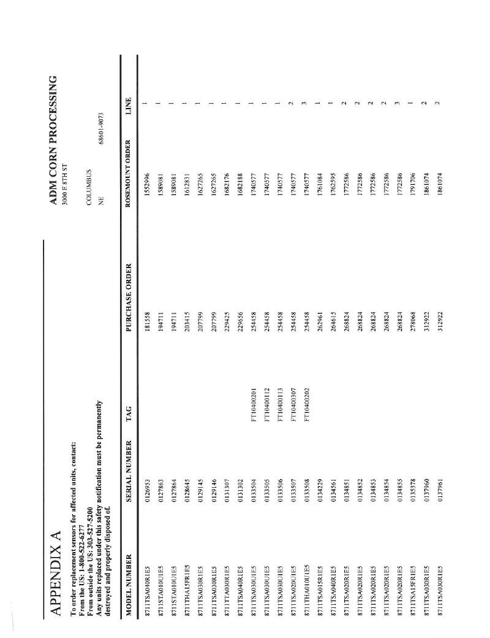
SAMPLE

